DATE | 28-02-2026
TEAM ID | LTVIP2026TMIDS89110
PROJECT NAME | plugging into the future: an exploration of electricity consumption patterns using tableau
MAXIMUM MARKS | 4 MARKS

6.3 Data Preparation
Visualizing:
2019 State Consumption:
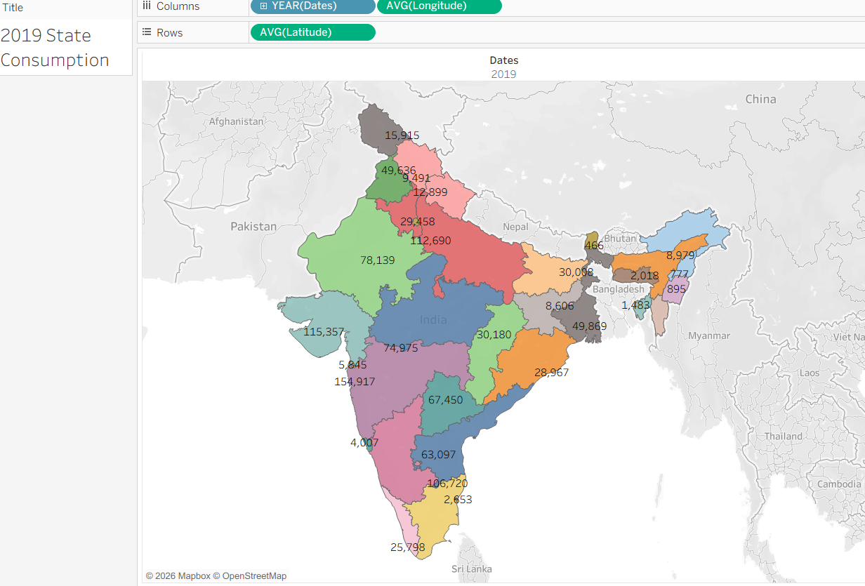

2020 State Consumption:
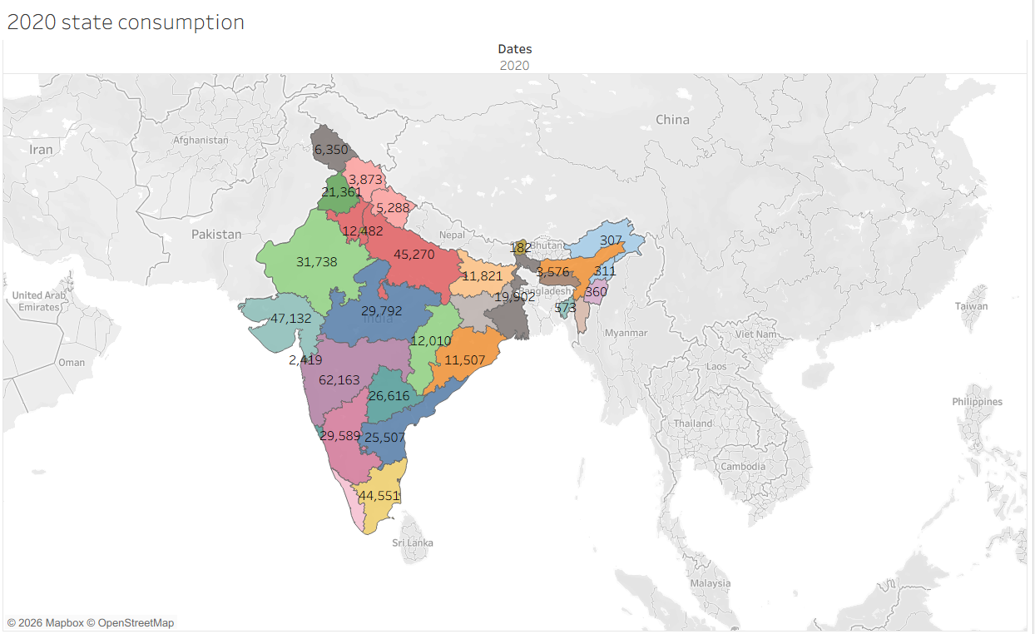
Total Consumption:
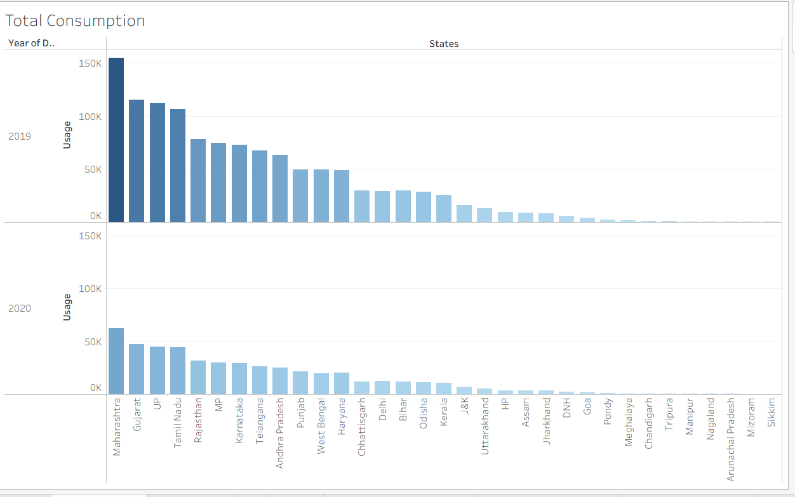

Usage by Region:
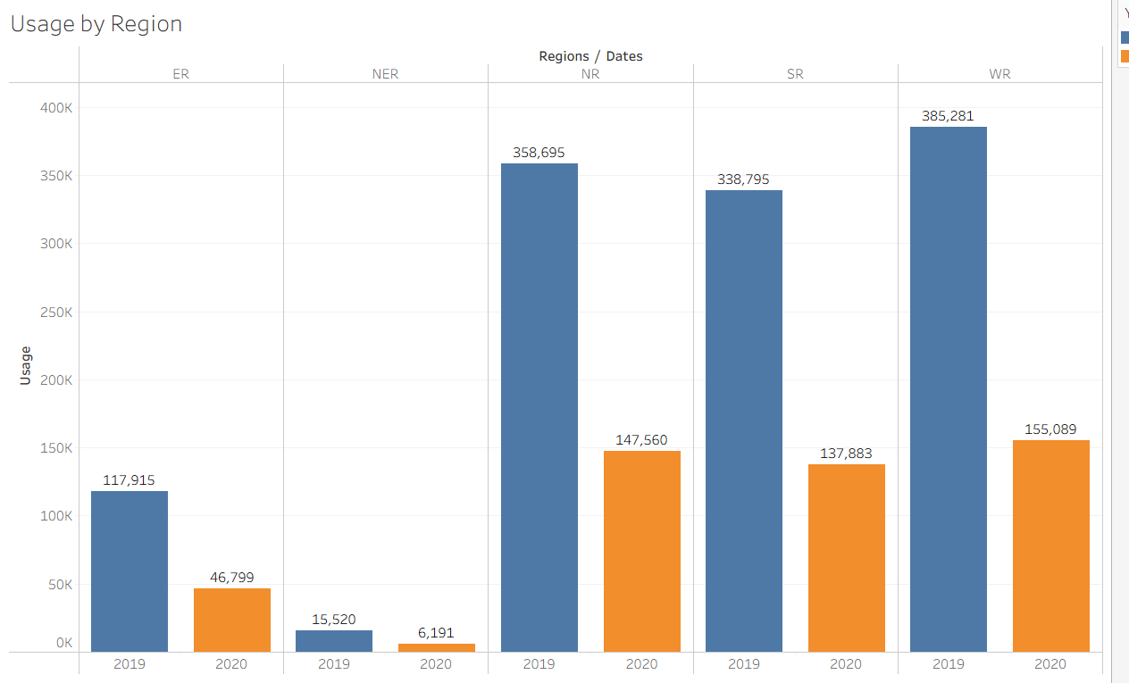
2019 Month wise Consumption:
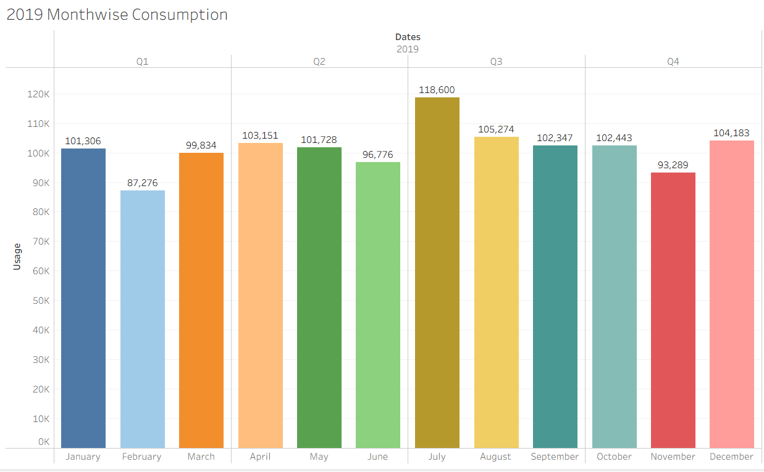

2020 Month wise Consumption: 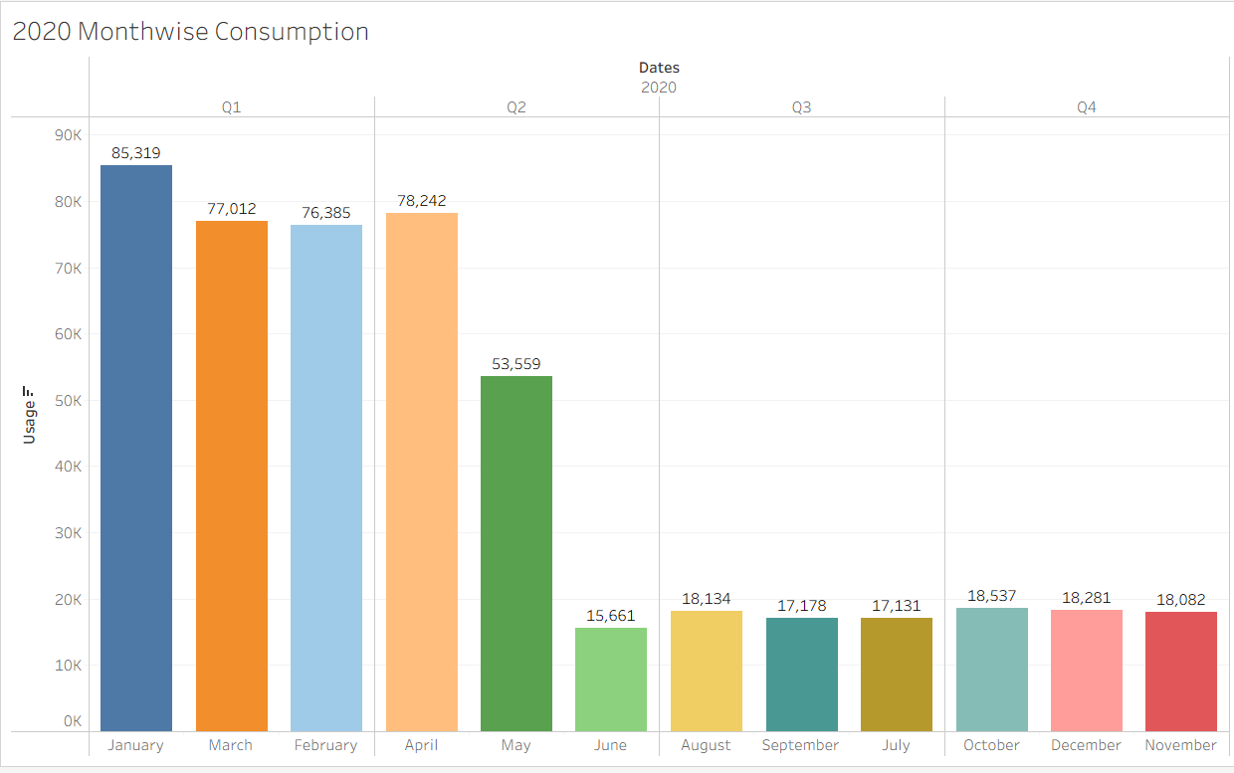
Total Region Consumption:
